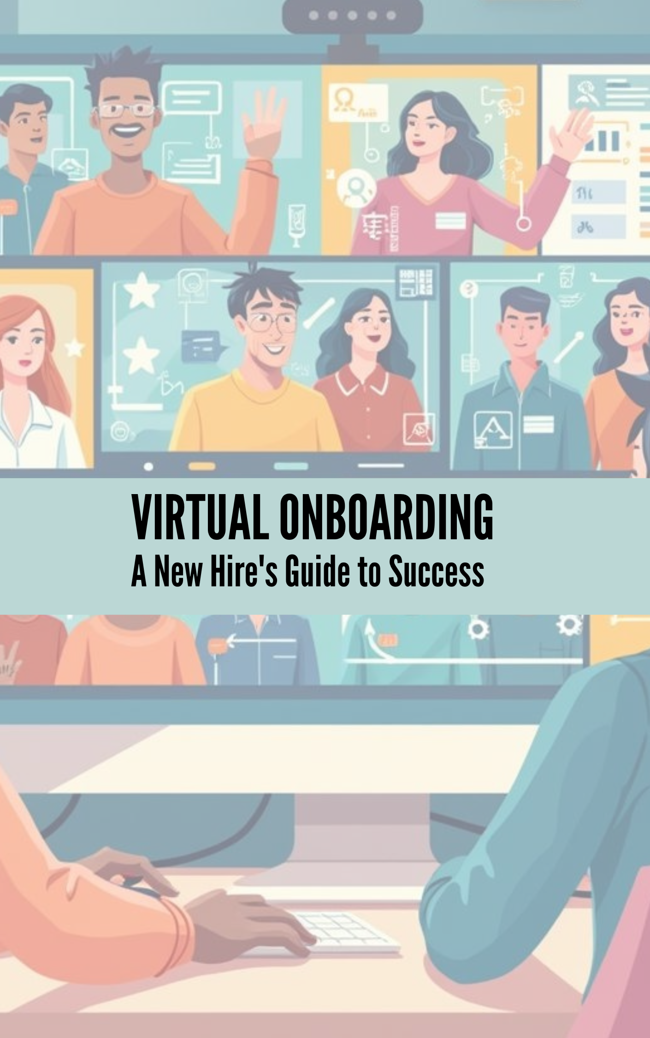

Virtual Onboarding: A New Hire's Guide to Success 1
Introduction: Start Strong—Your Guide to Virtual Onboarding 3
Your Pre-Day 1 Checklist: Tech, Tools & Workspace Setup 3
Actionable Setup Checklist 3
Pro Tip 4
Quick Win 4
Navigating Virtual Comms: Email, Chat & Video Call Etiquette 4
Knowing Your Tools 5
Email Essentials 5
Chat Etiquette 5
Video Call Basics 5
Common Pitfalls to Avoid 6
Pro Tip 6
Quick Win 6
Finding Your People: Proactive Connection Strategies 6
How to Build Connections Early 6
Tips for Impactful Digital Introductions 7
Common Pitfalls to Avoid 7
Quick Win 7
Understanding Your Role: The 'First 90 Minutes' Focus 7
Your Day 1 Decoding Process 8
Proactive Communication Makes a Difference 8
Pro Tip 8
Quick Win 9
Resource Roster: Where to Find What (and Who to Ask) 9
Must-Have Resource Bookmarks 9
Who’s Who: Your Virtual Contacts List 9
Best Practices for Finding & Organizing Resources 9
Pitfalls to Avoid 10
Pro Tip 10
Quick Win 10
Boundary Setting Basics: Managing Your Remote Workday 10
Actionable Boundary Strategies 11
Healthy Boundary-Setting in Action 11
Quick Win 11
Conclusion & Your Confident Start 12

Introduction: Start Strong—Your Guide to Virtual Onboarding
Starting a new job remotely or in a hybrid environment can be both exciting and overwhelming. It’s completely normal to feel uncertain about team culture, virtual communication etiquette, or even where to turn when you have a simple question. You might wonder: Will I feel isolated? How do I connect with my team? What’s expected from day one?
This ebook is your personal Virtual Onboarding Navigator—a clear, practical companion to help you thrive from your very first day. Our goal is to boost your confidence and get you connected, organized, and ready. Inside, you’ll find easy, step-by-step guidance on:
- Preparing your tech and workspace for smooth starts
- Navigating virtual communication channels like a pro
- Building meaningful relationships with your team—even from afar
- Understanding your role and immediate priorities
- Accessing the right resources and support
- Setting healthy work-life boundaries early on
No jargon. No guesswork. Just actionable tips and quick wins. A successful virtual start is not just possible—it’s right here at your fingertips.

Your Pre-Day 1 Checklist: Tech, Tools & Workspace Setup
The transition to a fully remote or hybrid job starts before your first official work hour. Many new hires arrive virtually, only to discover device hiccups, missing access, or an uncomfortable workspace—early snags that can disrupt your momentum and confidence. Taking charge now will set you up for a smooth, empowered Day 1.

Actionable Setup Checklist
- Device Delivery & Readiness: Ensure your company-issued laptop or desktop has arrived, powers on, and charges properly. Double-check that all included accessories—charger, mouse, headset—are working.
- Internet Connectivity: Test your home Wi-Fi for a strong, stable signal where you plan to work. If possible, keep a backup (like hotspot access) ready for emergencies.
- Install & Test Core Applications: Download and log in to essential apps, such as:
  - Email platform (e.g., Outlook, Gmail)
  - Chat tools (Slack, Teams, etc.)
  - Video conferencing (Zoom, Google Meet)
- Send yourself a test message or join a test call to verify all features work (camera/microphone, file sharing, screen sharing).
- Access Company Platforms: Confirm that you can log in to:
  - Company intranet or HR portal
  - Learning management system (LMS)
  - Shared drives or document repositories
- If access is denied or credentials are missing, notify your contact in advance.
- Run Security Updates: Install any pending software or security updates on your device to prevent vulnerabilities on Day 1.
- Workspace Ergonomics: Set up a dedicated, distraction-free workspace with:
  - A comfortable chair and supportive desk
  - Good lighting—avoid harsh backlighting for clear video calls
  - Camera positioned at eye level
  - Neutral, uncluttered background or use a professional virtual background
- Backup Communication Plan: Prepare an alternate way to reach your team (e.g., personal phone number or backup email) in case logins or apps fail.

Pro Tip
Take screenshots of any error messages you encounter while setting up. These will help IT or HR resolve issues more quickly if needed.

Quick Win
Complete this checklist before Day 1. You’ll walk into your first meetings feeling relaxed, connected, and ready to focus—not scrambling to fix tech issues or hunt for passwords. A little preparation unlocks confidence and a great first impression!

Navigating Virtual Comms: Email, Chat & Video Call Etiquette
Entering a new remote or hybrid role often means juggling several communication platforms—email, chat apps, and video calls—all at once. For many, this digital maze can feel a bit overwhelming at first. The good news? Understanding the strengths of each tool—and mastering some simple best practices—will set you apart and ease your transition.

Knowing Your Tools
- Email: Ideal for formal communication, sharing detailed updates, or reaching out across time zones.
- Chat (e.g., Slack, Teams): Perfect for quick questions, real-time collaboration, or casual check-ins among teammates.
- Video Calls: Best for meetings, brainstorming, and connecting face-to-face—even virtually.

Email Essentials
- Subject Line Power: Keep it clear and specific so recipients can easily prioritize.
- Be succinct: Use brief paragraphs with bullet points for clarity.
- Reply All with care: Only include those who truly need the information to avoid inbox overload.
- Professional greeting/sign-off: Especially on external or cross-team emails.

Chat Etiquette
- Use chat for speed: Quick questions, sharing files, or brief updates.
- Threads are your friend: Keep conversations organized and context clear by replying in threads.
- Be mindful of tone: Without vocal cues, warmth and clarity in written words matter.
- Limit @mentions: Use them only when a response is urgent or directed, rather than for general announcements.
- Respect status messages: If someone is set to “Do Not Disturb” or “Away,” avoid non-urgent pings.

Video Call Basics
- Be on time: Join calls promptly to show respect for everyone’s schedule.
- Camera on? Unless specified otherwise, turn on your camera in small meetings to foster connection.
- Mute when not speaking: Reduces background noise and distractions.
- Background check: Use a simple, uncluttered background or an approved virtual background.
- Engage respectfully: Use the chat for questions, reactions, or applause icons during group meetings.

Common Pitfalls to Avoid
- Overusing @mentions or direct messages—can lead to notification fatigue.
- Ignoring “Do Not Disturb” statuses—interrupts focused work.
- Missing calendar invites—double-check your calendar at the start of each day.

Pro Tip
Set your own status to show when you’re available, in focus mode, or offline. Use chat threads to keep team discussions tidy and prevent important info from getting lost.

Quick Win
Today, send a friendly introduction in your team’s main chat or email thread. Share a bit about yourself and invite colleagues to connect—this simple gesture builds instant rapport and signals your engagement.

Finding Your People: Proactive Connection Strategies
One of the biggest risks in remote and hybrid work is isolation. Without office hallways or impromptu coffee chats, it’s easy to miss out on the casual connections that help you feel like part of the team. Don’t let the virtual wall keep you on the outside—relationship-building starts with intention, and there’s plenty you can do from Day 1 (or even earlier).

How to Build Connections Early
- Introduce Yourself in Team Channels: As soon as you have access, post a short, friendly message in your main team chat, all-hands channel, or group email. For example:
  - “Hi everyone! I’m Jamie, your new product analyst. I’m excited to join the team from Toronto. Outside work, I love hiking and trying new coffee shops. Looking forward to working with you all!”
- Schedule Informal One-on-Ones: Don’t wait for invitations! Aim to set up ‘virtual coffees’ with 2–3 colleagues (including your manager or team buddy) during your first week. A simple conversation starter:
  - “Could we schedule a quick virtual coffee this week? I’d love to hear more about your work and any tips you have for getting started.”
- Ask for a Buddy or Onboarding Partner: Many organizations offer a buddy program—a more experienced teammate who can answer questions and help you acclimate. If this isn’t mentioned, proactively ask HR or your manager to be paired up.
- Explore Social or Interest Groups: Whether it’s a book club, fitness channel, or pet pics group, join at least one casual community to spark organic conversations beyond your work tasks.
- Leverage the Org Chart or Directory: Spend a few minutes reviewing the internal org chart or directory to see team roles and reporting lines. This makes it easier to know who to reach out to and personalizes your greetings.

Tips for Impactful Digital Introductions
- Share a little about your background—and something personal, like a hobby.
- Express enthusiasm to connect or collaborate. Positivity is infectious, even in text!
- When reaching out one-on-one, mention what you’re hoping to learn or share.

Common Pitfalls to Avoid
- Waiting for outreach: It’s easy to assume others will introduce themselves, but taking initiative signals your willingness to engage.
- Skipping optional chats and socials: “Optional” doesn’t mean unimportant—these interactions help you become a real member of the team.
- Disengaging quickly if replies are slow: Colleagues may be busy; patience and persistence pay off.

Quick Win
Action Item: Before your first week ends, schedule one virtual coffee with a teammate—ideally someone outside your immediate role. One genuine conversation can open doors and make your virtual workplace feel like home.

Understanding Your Role: The 'First 90 Minutes' Focus
Unclear expectations are one of the most common sources of confusion and stress for remote new hires—especially on Day 1. Without in-person cues or quick tap-on-the-shoulder moments, you might find yourself unsure where to get started or what’s urgent. Instead of letting uncertainty stall your momentum, use your first 90 minutes with intention to get clarity and direction.

Your Day 1 Decoding Process
- Review Your Job Description: Take a few minutes to re-read your official job description or offer letter. Highlight keywords, core responsibilities, and any metrics or deliverables mentioned.
- Check the Onboarding Schedule: Open your calendar or onboarding doc. Note all meetings (who, when, and why), training sessions, and Q&A slots scheduled for you this week.
- List Key Deliverables & Invites: Identify any specific assignments or tasks you’re expected to complete in the first week. Jot down due dates, owners, and direct links if available.
- Confirm Reporting Lines: Make sure you know exactly who you report to, and note any dotted-line leaders or buddies assigned for onboarding support.
- Initiate a Brief Check-In: Message or email your manager with a polite, focused question such as: “Could you clarify the top priorities for my first week? What does success look like by Friday?”
- Create a 'Priority Cheat Sheet': On a sticky note, digital doc, or notepad, write your three highest-impact action items for Day 1. Keep this visible for easy reference throughout your first week.

Proactive Communication Makes a Difference
Avoid the passive pitfall: Don’t wait until someone tells you exactly what to do. Take initiative—asking specific questions about your immediate tasks and feedback timelines demonstrates confidence and commitment.
- If something is unclear, flag it early. Your manager will appreciate your engagement.
- Use your notes from onboarding calls to update your cheat sheet with real-time expectations.
- Double-check that your work calendar is synced and you’re not missing any critical meetings.

Pro Tip
Don’t wait for regular check-ins to be scheduled— set up a recurring weekly 1-on-1 with your manager (even if brief) from the very beginning. This builds a feedback loop and provides a safe space to discuss your goals, blockers, and wins.

Quick Win
Action Item: Summarize your top three Day 1 goals in a short email or message to your manager. Sharing this shows initiative, invites feedback, and helps ensure you’re both aligned from hour one.

Resource Roster: Where to Find What (and Who to Ask)
In a remote or hybrid workplace, it’s completely normal to feel lost amidst a sea of online documents, unfamiliar platforms, and unknown contacts. Unlike an office, where you can glance over a colleague’s shoulder or ask around, virtual environments demand extra clarity and organization to get what you need—fast. Many new hires waste valuable time simply tracking down resources or guessing who handles what. Let’s make sure you don’t fall into that trap.

Must-Have Resource Bookmarks
- HR Portal: Your go-to for onboarding checklists, policies, benefits enrollment, and time-off requests.
- IT Support: Bookmark your company’s helpdesk or ticketing system for technical issues.
- Intranet / Internal Wikis: The central hubs for announcements, templates, SOPs, and team directories.
- Benefits Platform: Access health benefits, retirement info, and company perks.

Who’s Who: Your Virtual Contacts List
- Direct Manager: All role-specific questions, feedback, and weekly priorities.
- Team Buddy/Onboarding Partner: For “how do I...?” questions about team norms and day-to-day tools.
- HR Contact: Payroll, onboarding forms, benefits, compliance.
- IT Helpdesk: Device or app issues, passwords, access problems.
- Payroll/Finance Contact: Paychecks, reimbursements, or expense reports.

Best Practices for Finding & Organizing Resources
- Bookmark Essentials: Save all key resources in your web browser’s bookmarks bar. For apps, “pin” them to your desktop or app launcher.
- Use Company Search Tools: Practice using your intranet’s search or staff directory. Mastering search shortcuts saves hours later.
- Reference Knowledge Bases First: Before asking, quickly scan your company wiki or FAQ. Many answers live here!
- Keep a Personal Resource List: Use a digital note or spreadsheet to track contacts, links, and helpful docs. Update often for quick reference.
- Ask Clear, Concise Questions: When posting in group chats, be specific—e.g., “Hi team, where can I find the latest Q1 report template?” This shows initiative and respects others’ time.

Pitfalls to Avoid
- Not tracking who to contact for what—leading to repeated confusion.
- Letting important links get buried in chat history or emails.
- Asking broad questions in group channels before a quick search; this can frustrate busy teammates.

Pro Tip
Create a digital ‘Contacts and Links’ note (using OneNote, Google Keep, or even a simple doc). Add names, titles, email addresses, and URLs for your top resources. Keep it open alongside your workflow for instant access.

Quick Win
Before Day 1 ends, bookmark your HR portal, IT helpdesk, and intranet/wiki homepage. You’ll thank yourself every week—this tiny habit pays off immediately and prevents frustration when you need support fast!

Boundary Setting Basics: Managing Your Remote Workday
One of the hidden challenges of remote work, especially for new hires, is the risk of work-life boundaries blurring—or disappearing altogether. When your office is steps from your kitchen, it’s tempting to “just check one more email” late at night or over lunch, which can quickly add up to longer hours and, ultimately, burnout.
Developing simple, clear boundaries from Day 1 allows you to work efficiently while protecting your time, energy, and wellbeing. Here’s how you can set yourself up for a sustainable, confident routine—without guilt.

Actionable Boundary Strategies
- Define Clear Work Hours: Block your working hours on your digital calendar and communicate them to your team. Treat these hours as sacred—and respect your off-time just as much as your on-time.
- Set Physical Start/End Cues: Begin and finish your day with a specific action, such as turning on a desk lamp at 9am and off at 5pm, or shutting your laptop and leaving your workspace when you’re done.
- Communicate Your Availability: Use your chat, calendar, or email status to clearly state when you’re “Online”, “Available”, “In Focus Mode”, or “Away”.
- Plan Regular Breaks: Don’t skip lunch or stretch breaks. Schedule these on your calendar or use a timer to remind yourself to step away even if work is busy.
- Separate Work & Relax Spaces: If possible, keep your work area physically distinct from your relaxation or sleep areas. Even a small table or corner can help signal “work mode” versus “rest mode.”
- Fully Log Off at Day’s End: Shut down your computer and mute or pause work notifications after hours. Resist the urge to reply to messages the moment they come in—unless it’s genuinely urgent.

Healthy Boundary-Setting in Action
You might feel guilty setting limits or ignoring after-hours pings, but remember: healthy boundaries make you more effective and resilient in the long run. Here are some ready-to-use phrases for common situations:
- “I’ll be offline after 5pm, but I’ll respond first thing tomorrow morning.”
- “To respect my focus time, I'll respond to non-urgent messages after lunch.”
- “I take a break from 12–12:45 for lunch each day so I can bring my best energy to our projects.”
Pro Tip: Set a recurring daily reminder (e.g., 10 minutes before the workday ends) to log off and review your accomplishments. This simple habit prevents work from bleeding into your evening and gives closure to your day.

Quick Win
Action Item: During your first week, proactively share your working hours and communication preferences with your team—via group chat, status message, or a brief email. Setting expectations early helps everyone respect (and model) healthy boundaries.

Conclusion & Your Confident Start
With the right preparation, smart tools, and genuine connections, your virtual or hybrid start can feel both empowering and seamless. Embrace the flexibility remote work offers—while remembering that clear boundaries and proactive engagement are the keys to success. Each step you take, from introducing yourself to blocking work hours, builds your confidence and forges your place within the team.
- Take initiative early: Each small win grows your confidence.
- Use available resources: They’re there to support you.
- Reach out and connect: Relationships spark growth—even virtually.
You’re equipped and ready for this journey. Trust yourself—you have everything you need to make a strong, positive impact from Day 1!


www.keyfutureskills.com

